19th Apr 2025 – HNF PLANNING UPDATE
For links to PCC web sites regarding Planning and Licensing please see
the addendum at the end of this report.
~~~~~~~~~~~~~~~~~~~~~~~~~~~~~~~~~~~~~~~~~~~~~~~~~~~~~~~~~~~~~~~~~~~~~~~~~~~~~~~~~~~~~~~~~~~
LICENSING APPLICATIONS (NEW)
Tinside Lido - Hoe Road, Plymouth PL1 3DE
Application for the Grant of a Premises Licence:
Premises opening hours:
Monday to Sunday 6am to 1am
New Year's Eve into New Year's Day until 02:00 hours.
Summer Solstice usually 21st June early morning Swim/breakfast at 03:30 hours,
Between 11pm and 8am there will be total sound containment within the premises.
Permitted Activities
- Provision of plays indoors and outdoors: Monday to Sunday 8am to 11pm
- Provision of films indoors and outdoors: Monday to Sunday 8am to 11pm
- Provision of live music outdoors: Monday to Sunday 8am to 11pm
- Provision of live music indoors: Monday to Sunday 8am to 1am
- Provision of recorded music outdoors: Monday to Sunday 8am to 11pm
- Provision of recorded music indoors: Monday to Sunday 8am to 1am
- Provision of dance indoors and outdoors: Monday to Sunday 10am to 11pm
- Provision of late night refreshment indoors and outdoors: Monday to Sunday 11pm to Midnight
- Sale of alcohol for consumption on the premises: Monday to Sunday 10am to 12.30am
~~~~~~~~~~~~~~~~~~~~~~~~~~~~~~~~~~~~~~~~~~
PLANNING APPLICATIONS (NEW)
25/00567/FUL – 1 Radford Rd
Change of use from language school (Class F1) to 13no. residential apartments (Class C3), inc. roof extension, demolition of courtyard buildings, external alterations, and landscaping.
A bike store will be located off of Great Western Road to enable active travel for residents. It is proposed that the site is a car free development due to its sustainable location and restricted site area.
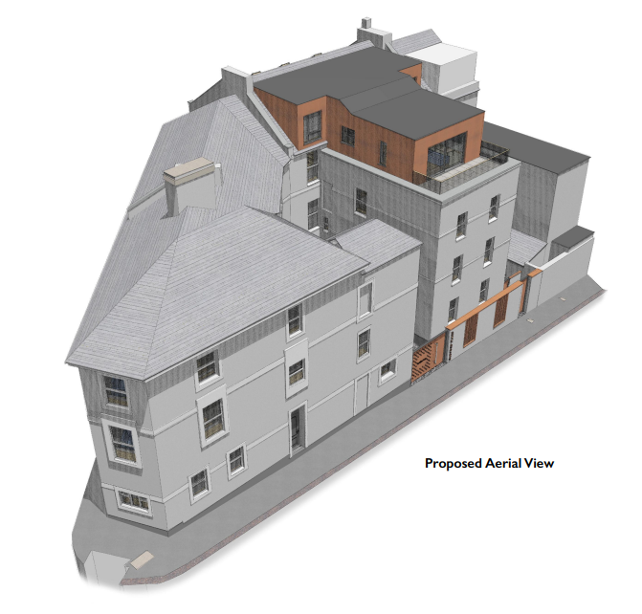
Comments by 6th May
~~~~~~~~~~~~~~~~~~~~~~~~~~~~~~~~~~~~~~~~~~
PLANNING APPLICATIONS (NEW)
25/00531/FUL - Flats 1 - 40, Citadel Court, 2 Elliot Street
Installation of rooftop handrail
The proposal is to install a new handrail at roof level (on the flat roofs) in order to provide safe access for maintenance purposes. There will be no use of the flat roofs as a roof terrace.
The windows and doors will also be replaced; however, this will be new uPVC to match existing (colour and opening pattern) and so planning consent is not required for this element.
Comments by 29th Apr
~~~~~~~~~~~~~~~~~~~~~~~~~~~~~~~~~~~~~~~~~~
25/00504/FUL - Flat 5, 24 Elliot Street
Replacement casement window and external staircase
This is the full planning application after the Listed Building Consent 25/00052/LBC was granted.
Comments by 29th Apr
~~~~~~~~~~~~~~~~~~~~~~~~~~~~~~~~~~~~~~~~~~
25/00280/FUL - 10 Sussex Place
Ground floor and first floor rear extension with balcony and roof terrace above.
This proposal raises the existing roof patio up by one floor plus a single storey ground extension which will match the neighbouring properties existing height.
The PCC Historic Environment Office have stated “acceptable with conditions” on the materials to be used.
Comments by 5th May
~~~~~~~~~~~~~~~~~~~~~~~~~~~~~~~~~~~~~~~~~~

PLANNING APPLICATIONS (PREVIOUS)
25/00385/FUL – 2 Alfred Street
Change of use of hotel/guesthouse (Class C1) to single dwellinghouse (Class C3)
The application is for a change of use for the property from a hotel/guesthouse to a single dwelling house. This change would revert the property to its original use, which can be seen a positive change and maintain its’ long-term viable use as a valued heritage asset.
Awaiting Decision
~~~~~~~~~~~~~~~~~~~~~~~~~~~~~~~~~~~~~~~~~~
25/00422/MOR - 2 Pier Street (Former GP surgery, now vacant site)
Pre-application advice sought for a temporary car park
During a previous enquiry, for a retail unit, PCC required additional residential development above it and this attracted concern over parking impacts. The applicant is concerned that a mixed-use scheme is not viable and is not looking to proceed with this proposal as a result. This enquiry proposes a temporary use until such time as a long-term proposal can be established and would improve the current appearance of the site and put it to a more effective use.
Awaiting Decision
~~~~~~~~~~~~~~~~~~~~~~~~~~~~~~~~~~~~~~~~~~
25/00293/LBC - Flat 26 (4th Floor (Attic)), 24 Elliot Street
Replacement sash windows and doors to improve thermal performance
Awaiting Decision
~~~~~~~~~~~~~~~~~~~~~~~~~~~~~~~~~~~~~~~~~~

PLANNING APPLICATIONS (PREVIOUS)
25/00263/FUL - 9-13 Lockyer Street (Old YWCA)
An application has been received, on behalf of the Fairhome (specialist vulnerable housing) Property Group, for front façade alterations for the installation of ventilation involving ‘filling in’ of some existing wall penetrations and drilling some new ones.
Granted
~~~~~~~~~~~~~~~~~~~~~~~~~~~~~~~~~~~~~~~~~~
23/01796/FUL (re-submission of 22/01119/FUL) & 23/01797/LBC -(re-submission of 22/01117/LBC)
Hoe Lodge Restaurant (Grade 2 listed), Hoe Road
Rear and side extension plus roof terrace and internal alterations
PRE-COMMENCEMENT
No development approved by this permission shall be commenced until details of a scheme for the provision of surface water management has been submitted to and approved in writing by the Local Planning Authority. SWW should be consulted for any surface water drainage strategy that proposes to connect to the existing SWW sewerage system and written confirmation of approval from SWW should be submitted, including agreed surface water discharge rates before the drainage proposals are accepted.
Before any work hereby permitted commence, [excluding demolition to slab level, archaeological evaluation and site investigation works] the applicant shall secure the implementation and completion of a programme of archaeological mitigation works, an archaeological watching brief, in accordance with a written scheme of investigation, which shall be submitted to and approved in writing by the Local Planning Authority. The works shall be carried out in accordance with the approved details.
No development shall take place beyond damp proof course until details of the landscape works have been submitted to and approved in writing by the local planning authority.
Notwithstanding the approved elevation plans, development shall not proceed past damp proof course, until full details of the materials to be used in the construction of the external surfaces of the development alongside further details of the treatment of the junctions between the original building and extension hereby permitted have been submitted to and approved in writing by the Local Planning Authority.
CONDITION: OPENING HOURS
The use of the site hereby approved shall not be open to customers outside the hours of:
0800 - 2230 Monday to Friday
0800 - 2330 Saturdays, Sundays or Bank Holidays.
Granted subject to the above conditions
~~~~~~~~~~~~~~~~~~~~~~~~~~~~~~~~~~~~~~~~~~
PLANNING (MISCELLANEOUS)
Pier One, Hoe Rd & Corinthian, Madeira Rd
Unapproved Canopies
No further feedback from PCC who still state “they are investigating any actions to be taken.”
~~~~~~~~~~~~~~~~~~~~~~~~~~~~~~~~~~~~~~~~~~
ADDENDUM A
Planning – Viewing applications
You can view any of the planning applications listed below by visiting
https://planning.plymouth.gov.uk
and searching using the planning application number or address shown below.
~~~~~~~~~~~~~~~~~~~~~~~~~~~~~~~~~~~~~~~~~~~~~~~~~~~~~~~~~~~~~~~~~~~~~~~~~~~~~~~~~~~~
Planning - Commenting on applications
Comments can be submitted to Plymouth City Council by the methods below. Please include your name, address and the application number and clearly state if you ‘Object’ or ‘Support’ the application
- Email to: planningconsents@plymouth.gov.uk
- By post to: Strategic PCC Planning and Infrastructure, Floor 2, Ballard House, West Hoe Road, Plymouth, PL1 3BJ
- PCC Public Access Portal – You will need to have, or set up, a personal account for PCC access
~~~~~~~~~~~~~~~~~~~~~~~~~~~~~~~~~~~~~~~~~~~~~~~~~~~~~~~~~~~~~~~~~~~~~~~~~~~~~~~~~~~~
Planning – Reporting unauthorised developments:
https://www.plymouth.gov.uk/report-alleged-unauthorised-development
~~~~~~~~~~~~~~~~~~~~~~~~~~~~~~~~~~~~~~~~~~~~~~~~~~~~~~~~~~~~~~~~~~~~~~~~~~~~~~~~~~~~~
Licensing - Commenting on applications
https://licensing.plymouth.gov.uk/1/WcaHome
~~~~~~~~~~~~~~~~~~~~~~~~~~~~~~~~~~~~~~~~~~~~~~~~~~~~~~~~~~~~~~~~~~~~~~~~~~~~~~~~~~~~~
Report Noise Issues (businesses or neighbour’s)
https://www.plymouth.gov.uk/noise

